Leetcode Problem 2. (Easy)

Merge Two Sorted Lists

You are given the heads of two sorted linked lists list1 and list2.

Merge the two lists in a one **sorted** list. The list should be made by splicing together the nodes of the first two lists.

Return *the head of the merged linked list*.

**Example 1:**

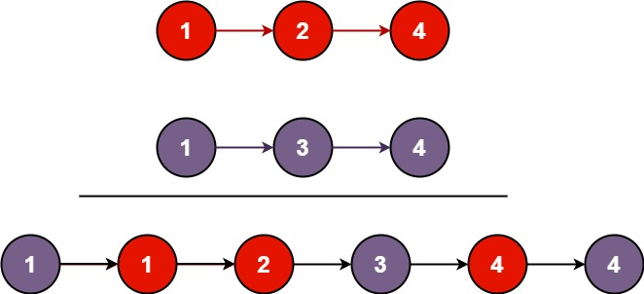

**Input:** list1 = [1,2,4], list2 = [1,3,4]

**Output:** [1,1,2,3,4,4]

**Example 2:**

**Input:** list1 = [], list2 = []

**Output:** []

**Example 3:**

**Input:** list1 = [], list2 = [0]

**Output:** [0]

**Constraints:**

* The number of nodes in both lists is in the range [0, 50].
* -100 <= Node.val <= 100
* Both list1 and list2 are sorted in **non-decreasing** order.

Link : <https://leetcode.com/problems/merge-two-sorted-lists/>

public class Solution {

public ListNode mergeTwoLists(ListNode list1, ListNode list2) {

ListNode mergedList = new ListNode(-1);

ListNode current = mergedList;

while (list1 != null && list2 != null)

{

if (list1.val <= list2.val) {

current.next = list1;

list1 = list1.next;

} else {

current.next = list2;

list2 = list2.next;

}

current = current.next;

}

if (list1 != null) {

current.next = list1;

} else {

current.next = list2;

}

return mergedList.next;

}

}